Classification codes
Washing machine heater

Task code 5EC002

Description This objective task involves an understanding and application of the physics involved in the operation of an outdoor heating device. It deals with expansion of a gas when heated, changes in pressure, and the reactants needed for the fire.

Conceptual strand / context Natural and processed materials Life and living
Energy and change Earth and beyond

Task type Objective Open ended Practical

Learning outcome focus Concept Process

Task focus level 1 2 3 4 5 6

Assessment purpose Diagnostic Formative Summative

Keywords radiation, convection, conduction

Items | 1 | 2 | 3
Highest scientific literacy level
Conceptual strand / context
Domain
Response type
Assessment purpose

Task / Teacher record sheet

Student: _______________________

To celebrate her team winning the football grand final, Denise went to a party. It was a cold day and the host had provided an effective outdoor heater for parties. It was made from the stainless steel barrel of an old washing machine. A wood fire was burning in the bottom of the barrel. To her astonishment Denise noticed flames inside the barrel apparently coming from the holes in its sides.
People stood around the fire with their hands over the opening in the top. Denise found her hands were warm on both sides but her body was only warm at the front.

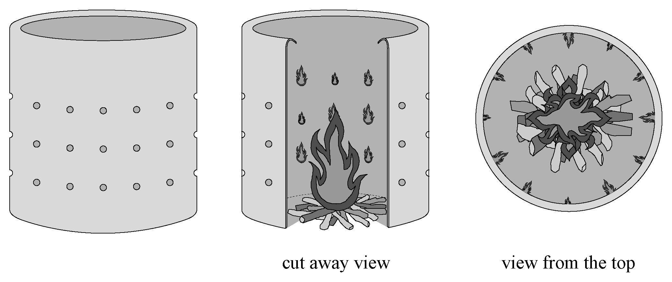

5EC002Q1

- Denise had warm hands and a warm front but her back was cold because
A radiant heat was the only heat reaching her body and hands.
B convection was the only method by which heat could reach her
body and hands.
C the heat reached her hands by convection and radiation and her body
by radiation only.
D the heat reached her hands by convection and radiation and her body
by convection only.

5EC002Q2
- Where were the reactants coming from for the flames at the holes inside the barrel?
A Wood placed in the bottom of the barrel.
B Air inside the barrel and gas from the burning wood.
C Air outside the barrel and gas from the burning wood.
D The barrel itself was made of flammable material.

5EC002Q3
- Explain as fully as you can why flames appeared to be coming in through the holes
in the sides of the barrel. Include reference to convection and pressure concepts
in your answer.

Marking guide
5EC002Q1
Q1 | Score 1 | [5C–hard. Explains phenomenon in terms of several abstract concepts (convection and radiation).]  C The heat reached her hands by convection and radiation and her body by radiation only.
 | Score 0 | Other.

5EC002Q2
Q2 | Score 1 | [5C–medium. Explains phenomenon in terms of several abstract concepts (recognise reactants for combustion).]  C Air outside the barrel and gas from the burning wood.
 | Score 0 | Other.

5EC002Q3
Q3 | Score 3 | [6C–easy. Explains complex system involving several abstract concepts and the relationship between them (recognises that reactants and conditions for combustion change in a specific situation).]  Components of the response:  - Lowered air pressure inside the barrel compared to outside gives rise to air being drawn in.  - The lower pressure inside the barrel is the result of heating the air inside and, as a consequence, air escaping out through the top.  - Materials in the wood are being gasified by the heat but are not being completely burned at the site of the wood fire.  - Unburned gases from the wood are rising up, combining with incoming oxygen at the holes in the sides, and combusting due to the level of heat in the barrel.  Example: The fact that the flames emerge inside the barrel from the holes in the sides indicates that air is being drawn into the barrel and supplying the oxygen for burning. It will only be drawn in if the pressure inside the barrel is lower than that outside. This is the case, as the wood burning inside the barrel is heating the air, expanding it and causing it to rise. This requires air to be drawn in as replacement. The heat produced by the burning wood is gasifying materials in the wood such as resins. Some of those flammable gases are not burnt at the source but are rising up with the air and thus provide, with the incoming oxygen, fuel for the fires seen at the holes.  Actual student response:  - As the hot air inside the barrel rose out, it was replaced by air getting pushed in from the outside due to air pressure. Convection currents caused air to come into the bottom of the fire which ignited at the holes.

 | Score 2 | [5C–hard. Explains phenomenon in terms of several abstract concepts (identifies reactants and conditions for combustion).]  Components of the response:  - Any subset of the conceptual elements outlined in the higher level answer and meeting the conditions for a level 5 response  Actual student responses:  - Fire feeds on oxygen. So the oxygen inside the barrel was all used up by the fire. The next source of oxygen was the outside, which has been coming from the holes. The holes are small and the fire eagerly wants the oxygen. So the fire developed around the holes as the fire eagerly ate away the small deliverance of oxygen.  - Because the air outside helps ignite the flames which go through the holes, with help from the gas from the burning wood and through convection the air circulating around the washing machine heater.
 | Score 1 | [4C–hard. Explains effects in terms of an abstract concept (locates one reactant for combustion).]  Components of the response:  - The idea that air is coming from outside the barrel through the holes.  or  - The gaseous fuel is on the inside of the barrel only.  or  - Rising hot air pulls cold air into the barrel through the holes.  or  - Other single abstract scientific concept applicable to the phenomenon.  Examples:  Flames emerge inside because the air is coming from outside the barrel.  or  The flames are on the inside of the barrel because that is where the gas from the wood is.  Actual student responses:  - Metal absorbs heat until it melts. Since fire needs fuel to burn and oxygen, the fire has spread where there is more oxygen. The holes in the barrel let air come in more quickly than the top, because the top oxygen has already burnt out.  - The flames appeared to be coming out of the holes in the sides of the barrel but on the inside because cold air from the atmosphere was mixing with the heat from the flame and flames were coming out of the barrel.  - The air is pushing the flames inside the barrel and it makes it look as if it were coming out the holes.
 | Score 0 | Other.

